ICCA Operator

## Operator Installation

## Follow below steps to install ICCA Operator

1. Login to your OpenShift.
2. Git Clone <https://github.com/rhm-samples/icca-operator-scripts>

$ git clone https://github.com/rhm-samples/icca-operator-scripts.git

1. Change directory to icca-operator-scripts

$ cd icca-operator-scripts

1. Make the installation script executable

$ chmod 755 Installation.sh

1. Run the Script to install the operator

$ ./Installation.sh

Operator will install in *icca-operator* namespace

1. Wait for installation script to complete. The script will subscribe to the operator and create CR instance of Catalog.
2. After Successful execution of the script, you’ll get the icca-ui route

===========Catalog URL==============  
http://icca-ui-icca-operator.ibm-cluster.us-south.containers.appdomain.cloud

## ICCA Catalog

1. Open the URL obtained in previous step to access ICCA Catalog

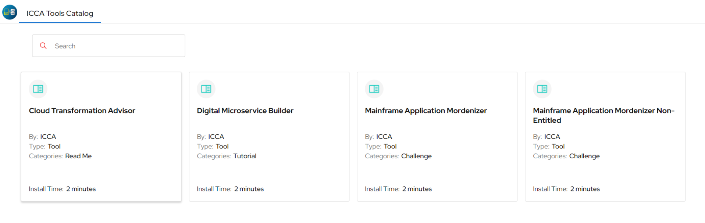

1. Description of the tiles in the dashboard

|  |  |  |
| --- | --- | --- |
| Tile | Helm Chart | Namespace |
| 1st Tile | Nginx | demo-nginx |
| 2nd Tile | Nginx + etcd multiple charts | demo-nginx-etcd |
| 3rd Tile | Nginx with private registry image | demo-nginx-pvt |
| 4th Tile | Nginx without entitlement key | demo-nginx-non-ent |

1. Click on tile to > click on ***Install*** button to install the helm chart

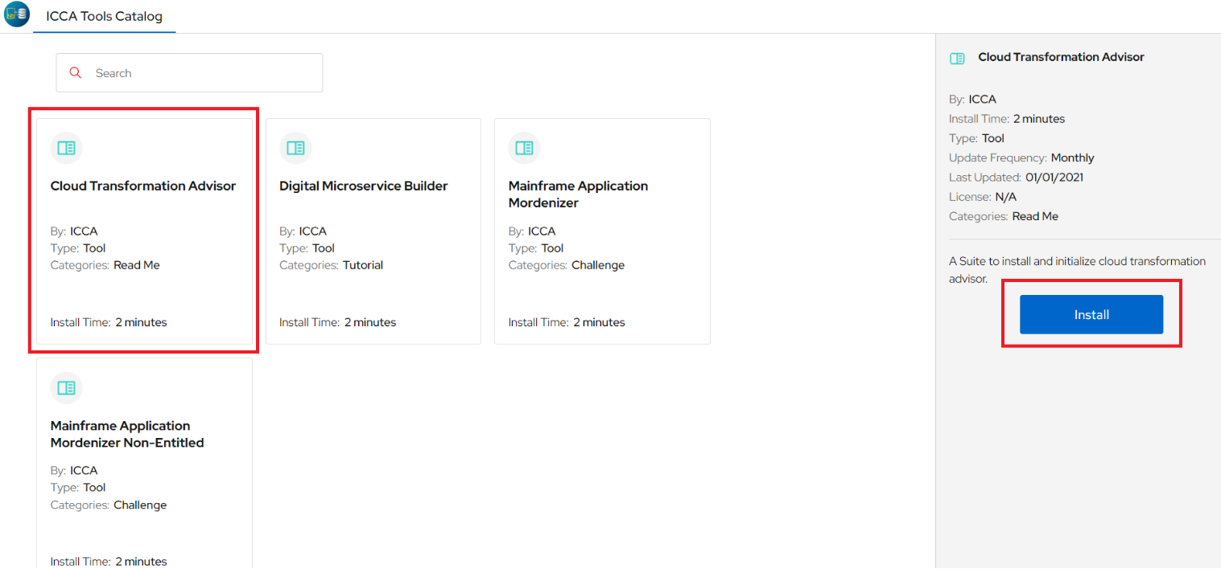

## Delete project from OpenShift

1. From left pane select Home -> Projects
2. Filter Projects using Name

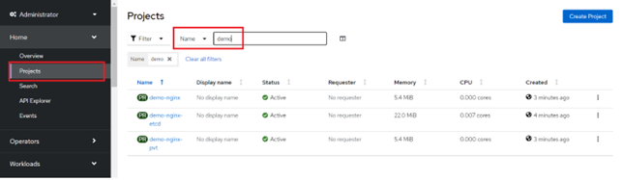

1. Click 3 verticle dots in front of project name.
2. Click on Delete Project.

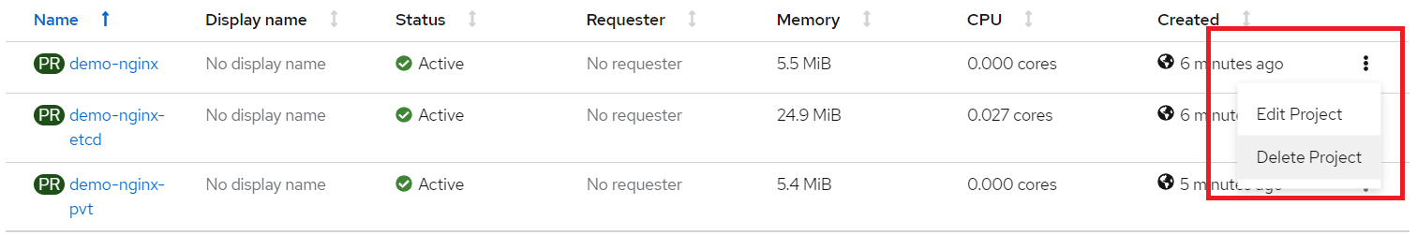

1. Enter name of project and click on Delete

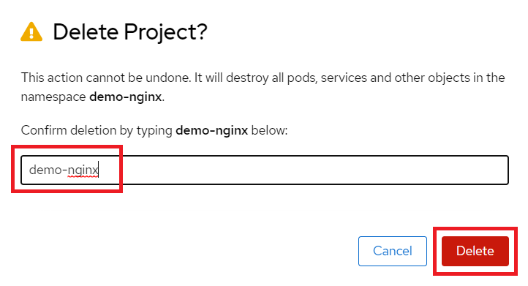

## Setup a global image pull secret

Setup a global image pull secret to pull the image from us.icr.io for Nginx with private registry image.

Doc reference: [Setting up the global pull secret for a registry| IBM Cloud Docs](https://cloud.ibm.com/docs/openshift?topic=openshift-registry#cluster_global_pull_secret)

Perform below steps to set IBM CLOUD API key as global pull secret.

oc extract secret/pull-secret -n openshift-config --keys=.dockerconfigjson --to=. --confirm

export encodedEntitlementKey=$(echo iamapikey:<IBM_CLOUD_API_KEY> | tr -d '\n' | base64 -w0)

export emailAddress=$(cat .dockerconfigjson | jq -r '.auths["cloud.openshift.com"].email')

jq '.auths |= . + {"us.icr.io": { "auth" : "$encodedEntitlementKey", "email" : "$emailAddress"}}' .dockerconfigjson >/tmp/dockerconfig.json

envsubst </tmp/dockerconfig.json >/tmp/.dockerconfigjson

After setting the global pull secret, reload each worker node. You can reload multiple worker nodes by including multiple -w flags, but make sure to leave enough worker nodes running at the same time for your apps to avoid an outage.

$ ibmcloud oc worker reload -c <cluster_name_or_ID> -w <workerID_1> -w <workerID_2>

1. After the worker nodes are back in a healthy state, verify that the global pull secret is updated on a worker node.
   1. Start a debugging pod to log in to a worker node. Use the **Private IP** that you retrieved earlier for the <node_name>.

$ oc debug node/<node_name>

* 1. Change the root directory to the host so that you can view files on the worker node.

$ chroot /host

* 1. Verify that the Docker configuration file has the registry credentials that match the global pull secret that you set.

$ vi /.docker/config.json